// Michael Haley

// Lab 3b

// This program will prompt for and then display student id, first name, last name, letter grade in math class, and the year.

// cin >> will be used for all inputs.

#include <iostream> // required for taking input and printing output

#include <iomanip> // required for setw & other formatting.

#include <string> // required to use string literals?

using namespace std; // sets the program to use the std namespace

int main() //calls the main function

{

int studentID, yearAttending;

string lastName, firstName;

char letterGrade; // these three lines declare my variables of types int, string, and char.

cout << "This program will take several inputs from you and then display those data." << endl; // explains the program to the user

cout << "Please input your Student ID Number: "; // prompts the user to input their data (A repeating)

cin >> studentID; // assigns input value to the variable (B repeating)

cout << "Please input your first name: "; // A

cin >> firstName; // B

cout << "Please input your last name: ";// A

cin >> lastName; // B

cout << "Please input the letter grade you received in Maths class: "; // A

cin >> letterGrade; // B

cout << "Please input the year you received this grade: "; // A

cin >> yearAttending; // B

cout << setw(12) << "Student ID #" << setw(12) << "Last Name" << setw(12) << "First Name" << setw(6) << "Year" << setw(6) << "Grade" << endl; // outputs the formatted line of column headers

cout << setw(12) << studentID << setw(12) << lastName << setw(12) << firstName << setw(6) << yearAttending << setw(6) << letterGrade << endl; // outputs the formatted line of data in columns

return 0; // resolves the main function

}

Run 1:

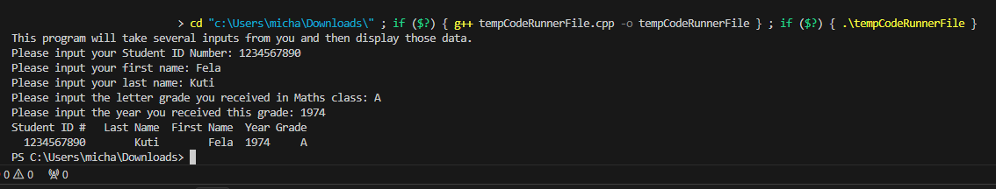

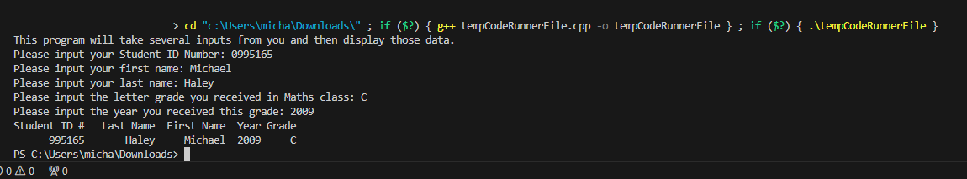Run 2: